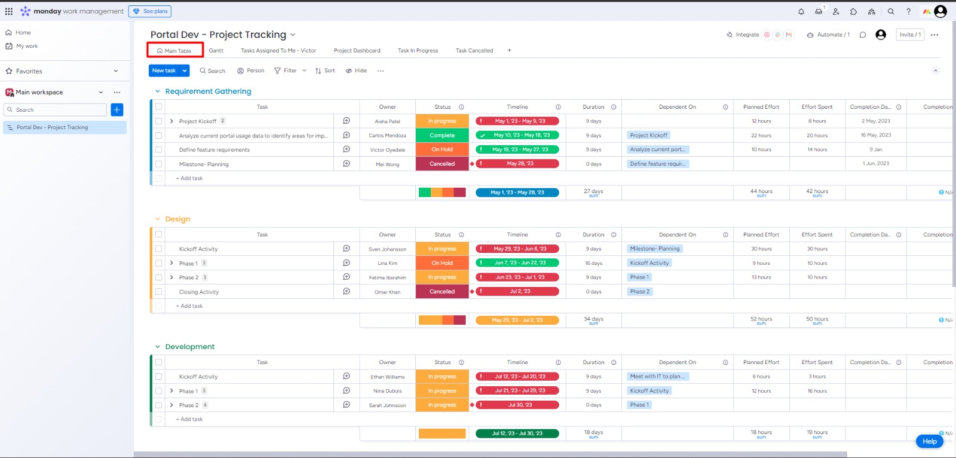

**Monday.com screenshot showing requirement gathering page 1**

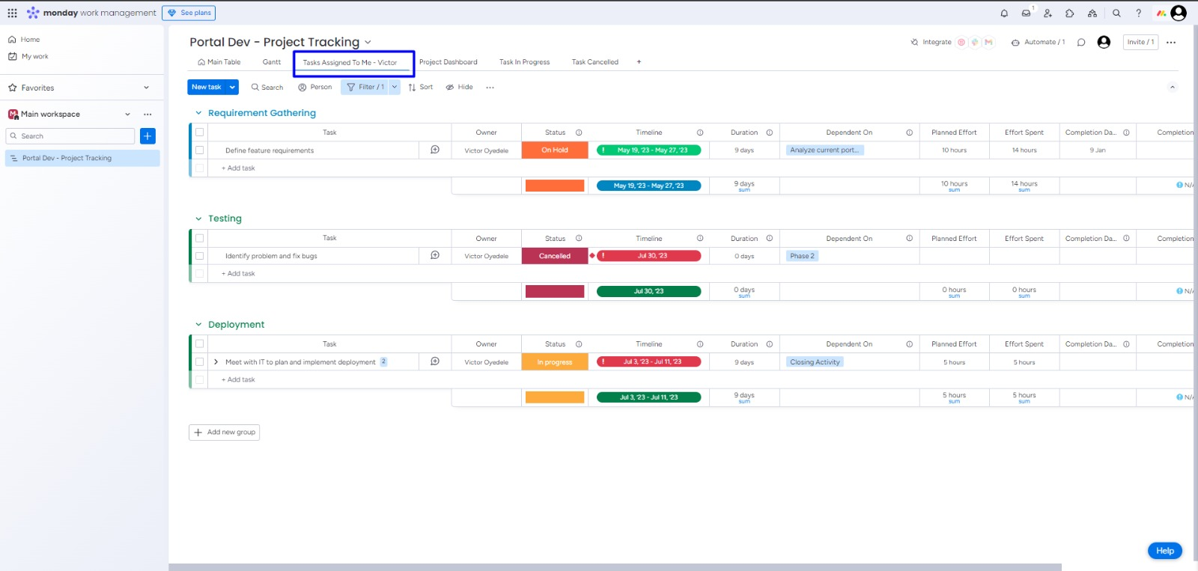

**Monday.com screenshot showing requirement gathering page 2**

**Monday.com screenshot showing Gantt**

**Monday.com screenshot showing dashboard overview**

